FC E-Nail by J-Cat

Instruction Manual

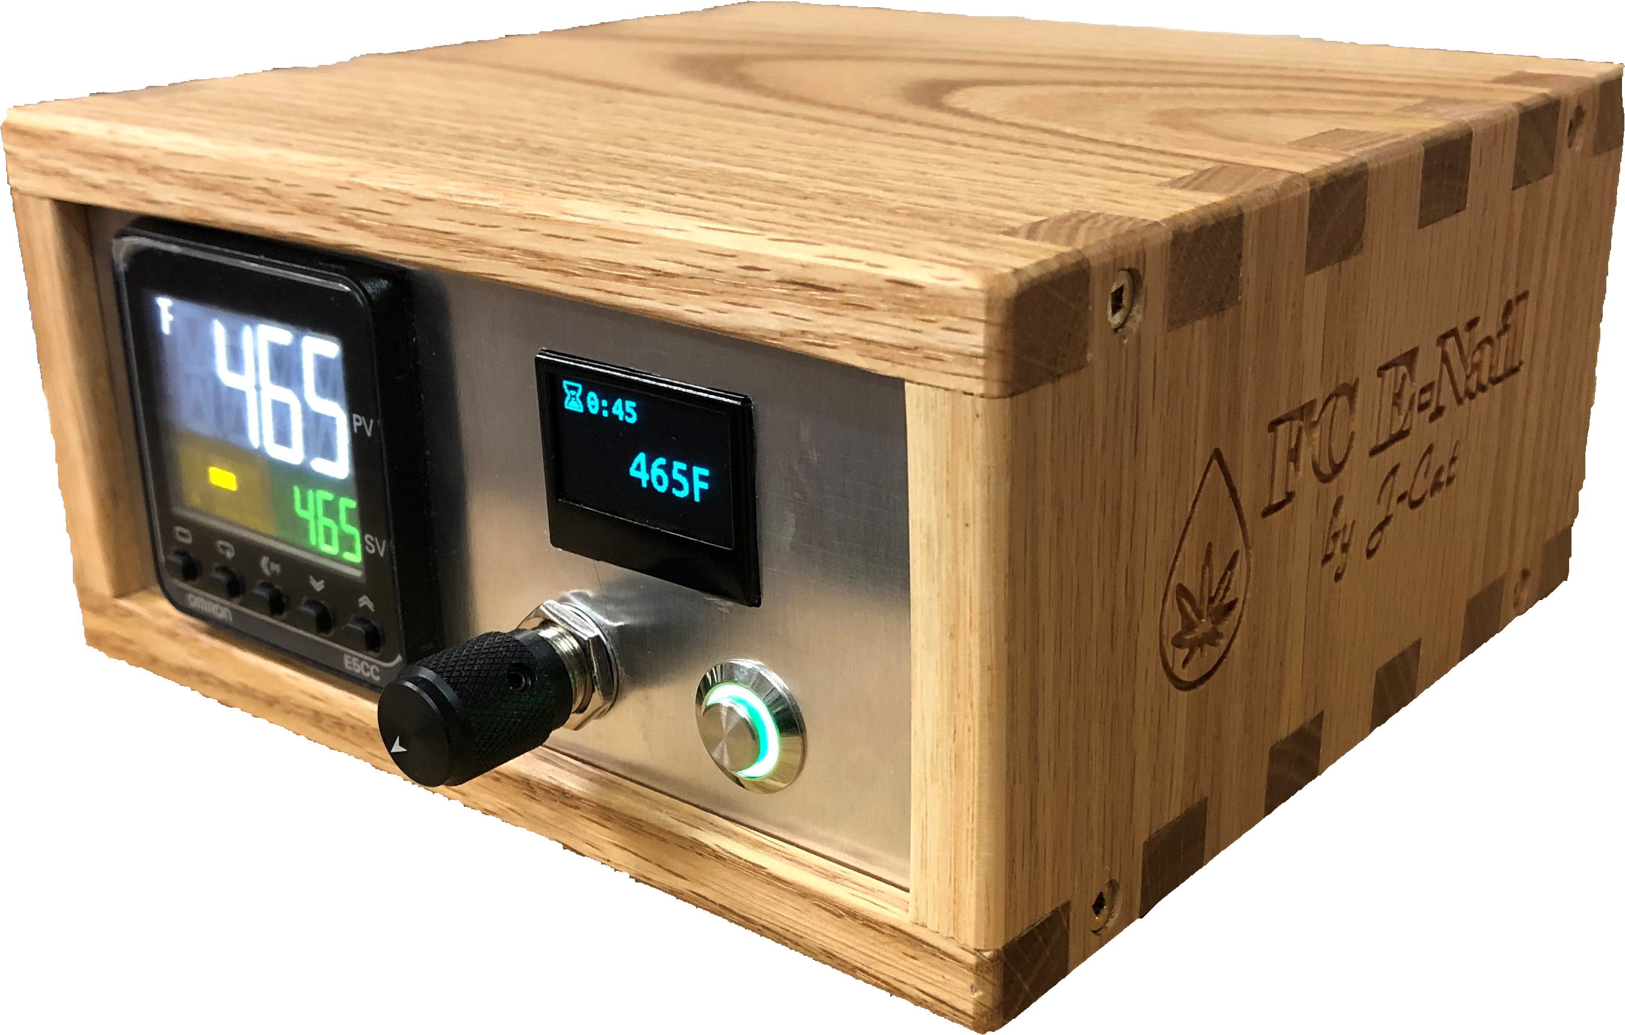

## Table of Contents

Table of Contents 2

Introduction 3

Navigation 4

Buttons 4

Menus 4

Adjusting Values 4

Numeric 4

Text 4

Home Menu 5

Favorites/Preset Menu 5

Scripts Menu 5

Profiles Menu 6

Auto-Tuning 6

Settings Menu 7

Presets 7

General Settings 8

Connect WiFi 8

Enable Hotspot 8

Network Info 9

Check for Updates 9

Support Shell 9

Web Application 10

Login 11

Home 12

Profiles 13

Scripts 14

Settings 15

Connect to WiFi 16

Known Issues 17

## Introduction

The FC E-Nail by J-Cat is an advanced, WiFi enabled e-nail (or PID controller); some of the features that differentiate this e-nail from alternatives are:

* Easy temperature adjustments with rotary dial
* Easy on/off of the heater both on the device and remotely
* Ability to save preset temperatures that can be accessed quickly from the device interface or mobile
* Create custom profiles for your different devices that you can load on-demand.
  + Auto-tune can be used to generate custom PID settings for each device (settings can also be adjusted manually)
  + A custom offset can be set for different devices so that what is displayed accurately reflects the floor temperature for all your different devices
* Create and run custom scripts for such things as up-temp procedures. This allows one to run simple to complex temperature change scripts for optimal consumption of your concentrate. These scripts can include:
  + Temperature changes
  + Delays
  + Sounds
  + Icons (on display and mobile device)
* Full mobile access including:
  + Remotely start, adjust temperatures, and monitor
  + Run scripts
  + Manage/create/edit scripts with the script editor (drag/drop GUI)
  + Manage profiles and launch auto-tune to generate
* Ability to connect device to WiFi network through device UI
* Automatic Updates

## Navigation

Navigation for the device interface is done through the rotary dial, the primary button, as well as the secondary button on the rotary dial.

### Buttons

The best way to think of the buttons, is the main one is the <enter> button, and the rotary dial/secondary one is the <escape> or <back> button.

Apart from the standard button clicks, one can also use *long* clicks, which involves holding the button down for more than half a second. A long click tends to act like a *context* click or a *double* click depending on the situation.

### Menus

Navigating between the menus is done by clicking on the secondary button when on the main menu screens; a regular click navigates to the next menu, whereas a *long* click navigates to the previous one.

When on a menu, you can scroll through the menu items with the rotary encoder and select an item with the primary button.

### Adjusting Values

#### Numeric

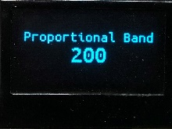When adjusting numeric values, use the rotary dial to change the value up/down, and use the primary button to confirm or the secondary button to cancel.

#### Text

When adjusting text values:

* use the rotary dial to move through the letters
* press the secondary button to change character sets (ie. capitals, symbols, etc.)
* press the primary button to enter/select a letter
* long press the primary button to confirm
* long press the secondary button to cancel
* *\*note: you can also change character sets, and confirm/cancel from the options below the characters.*

## Home Menu

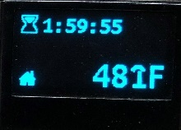 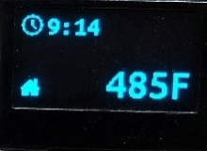

The *Home* menu is characterized by the Home icon  which is displayed in the lower left corner of the screen. From the *Home* menu, one can perform the following:

* The rotary dial adjusts the temperature up/down
* Clicking the primary button turns on/off the heater
* *Long-clicking* the primary button starts the currently selected script (one can change the currently selected script from the *Script Menu* or from the web app)

## Favorites/Preset Menu

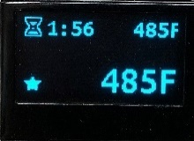

The Favorites (or Presets) menu is characterized by the Star icon . The functionality from the favorites menu is the same as that of the Home menu except that the rotary dial scrolls between the defined presets. The presets themselves can be adjusted (add/edit/delete) from the Settings -> Presets menu. On the presets screen, the currently selected preset is displayed in the top right of the screen.

## Scripts Menu

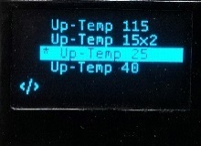

The Scripts menu is characterized by the *code* icon . From the scripts menu one can *select* the current script and *run* a script. The currently selected script is characterized by the * to the left of it. In order to create and edit scripts, one must use the web application (creating/editing scripts is the only feature that is accessible *only* from the web application)

Once a script is running, it will provide feedback on the display as well as through sound; pressing any button will cancel the script and the temperature will return to the original temperature from before the script was started.

## Profiles Menu

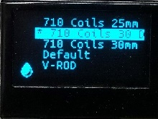

The Profiles menu is characterized by the drop icon  and allows one to configure different PID settings and offsets for different devices that you hook up to your controller. This allows one to always have your e-nail configured optimally for each different device, at the click of a button, that displays the correct floor temperature of each different device.

* Click the primary button to load a profile
* *Long* click the primary button to view the context menu for the currently *highlighted* profile:

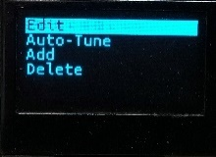

From the context menu, one can:

* + edit or delete the currently profile  
    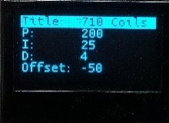 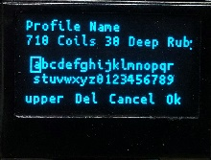 
  + auto-tune the current profile (see *Auto-Tuning* next)
  + add a new profile

### Auto-Tuning

When one auto-tunes a profile, this will run through a 5-10 minute process that ramps up/down the temperature on your device by 10-20 degrees a number of times to determine the optimal PID settings for the current device. *It is worth noting that one should first let a device heat up for 5-10 minutes until it stabilizes before running the auto-tune process.*

It is generally worth creating a new profile, and running an auto-tune process for each device that you own. Once this has been done once, you can simply call up the previously tuned profile at will.

When the auto-tune is running, the following will be displayed on the screen:

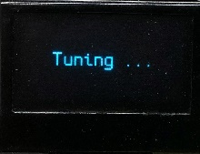

To cancel the auto-tune process, click any button on the device.

## Settings Menu

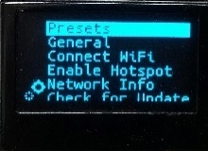 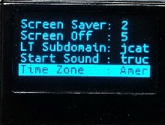

The Settings menu is characterized by the *gears* icon  and allows you to adjust all the miscellaneous settings on the device, including:

* Add/Delete/Re-Order Presets
* General Settings (volume, min/max temperature, auto-shutoff timeout, screen saver timeout, screen-off timeout, startup sound, time zone)
* Connect to WiFi
* Display Network Information
* Check for Updates
* Enable the Support Shell

### Presets

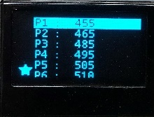

From the Presets menu, the primary button allows you to modify the value of the preset; once selected you use the rotary dial to change the value and the primary button to confirm the change or the secondary button to cancel it.

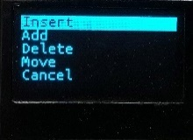If you *long* click the primary button, you will be presented with a menu that allows you to Insert or Add a new preset, and Move or Delete the selected preset.

### General Settings

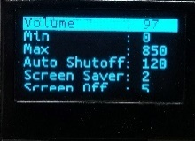 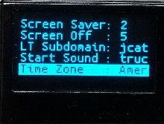

The General Settings menu allows you to adjust the following miscellaneous settings:

* Volume
* Min/Max temperature
* Auto Shutoff timeout (in minutes—default of 60)
* Screen Saver timeout (in minutes—default of 2)
* Screen Off timeout (in minutes—default of 5—screen only goes into off mode when the heater is off, as otherwise it is always updating with the countdown timer)
* LT Subdomain: This is the sub-domain that your device requests from LocalTunnel (loca.lt) for external HTTPS access to your device from outside your network. If none is specified, your device will not be externally accessible
* Start Sound: The startup sound that is played when your device starts up
* Time Zone: The time zone for your device; so the correct time is displayed when it is connected to the Internet. (default is Eastern Standard Time—America/Toronto)

### Connect WiFi

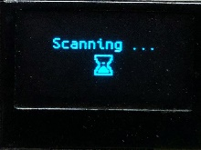

Connect WiFi allows you to do what you would expect, which is to scan and connect to available WiFi networks. Once initiated, it will scan for networks, and then display a list to select from; once you select a network, it will prompt you to enter the password, and if you do so correctly it should connect.

Once connected to the network, you can view your network information (IP Address, etc.) from the “Network Info” menu option.

### Enable Hotspot

Enable Hotspot enables the FC E-Nail Hotspot connection, that you can connect to in absence of a WiFi connection. This allows you to connect to your device with your mobile phone or PC by connecting directly to it’s WiFi. The downside of this method is of course that the e-nail is not connected to the Internet, and thus cannot be accessed externally nor can it sync it’s time (however, you can update the time from within the web app to match that of the device you are accessing it from)

### Network Info

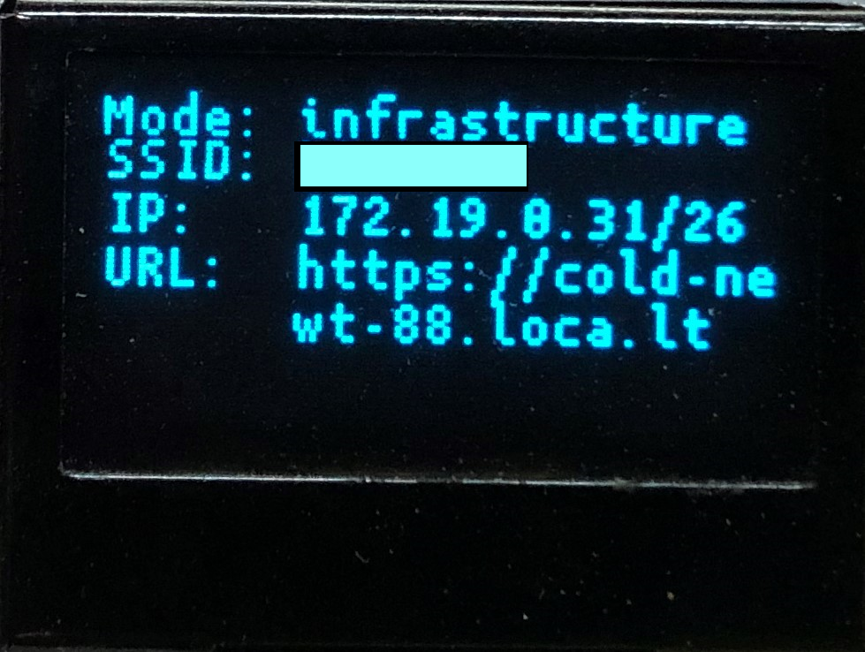

The Network Info menu option displays your current network information. This information can be used to determine the URL to connect to the web application from. For example, for the above network information, the correct URL to access the web application is:

* From your local network: <http://172.19.0.31>
* From the Internet: <https://cold-newt-88.loca.lt>

### Check for Updates

This option displays the current version, and enables you to manually initiate a check for updates. Your device must of course be connected to the Internet for this to work, and if not triggered manually, your device will check for updates daily at 4am if powered on and connected to the Internet.

### Support Shell

In the case that you require significant support, this option allows you to enable a remote support shell that only I can access. This option is only enabled if you enable it manually, otherwise I have no access to your device and no knowledge of it.

## Web Application

The FC E-Nail Web Application offers an interface to perform all the functions that you can directly on your device, as well as enables remote access. The one feature that is only available on the web interface is the ability to create and modify custom scripts.

To determine the web address (URL) of your FC E-Nail, go to “Settings” -> “Network Info” on the device, and then navigate to http://<IP_Address>

For example, for the following screenshot, the web address would be: <http://172.19.0.31>



Or, if accessing from outside your network over the Internet, it would be: <https://cold-newt-88.loca.lt>

### Login

The first time you access the web application from a new device (or at a new web address), you will be prompted to authorize the device.

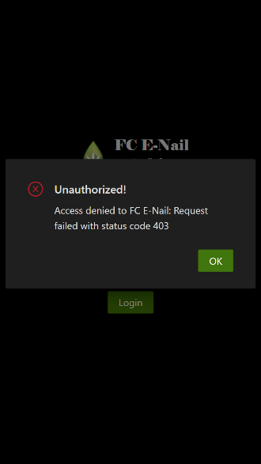

This is accomplished by entering a secret code that is displayed on the device itself (triggered by the unauthorized access).

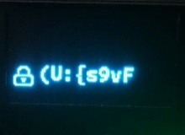 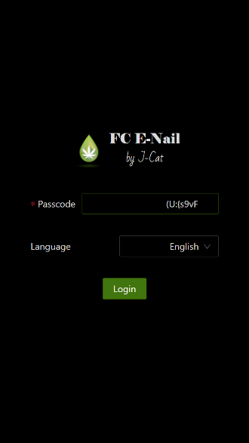

### Home

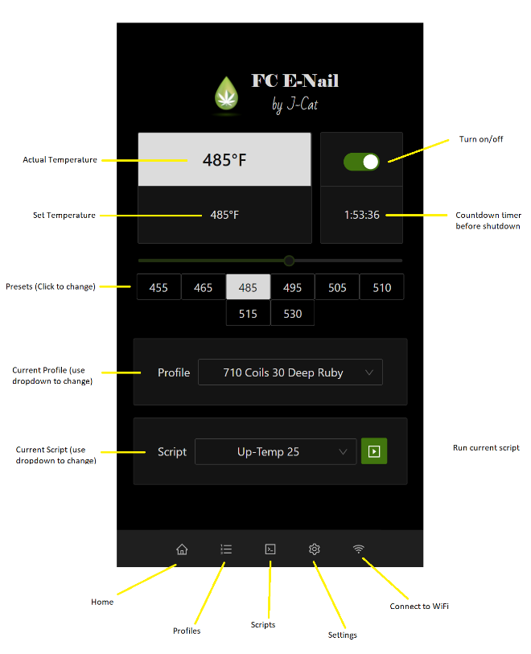

Once logged in, you will be taken to the Home screen; from there you can adjust the temperature (with the slider or presets), turn on/off the device, select the current profile, and select and run scripts.

I have endeavoured to make all common functions accessible from the Home screen in a logical manner.

### Profiles

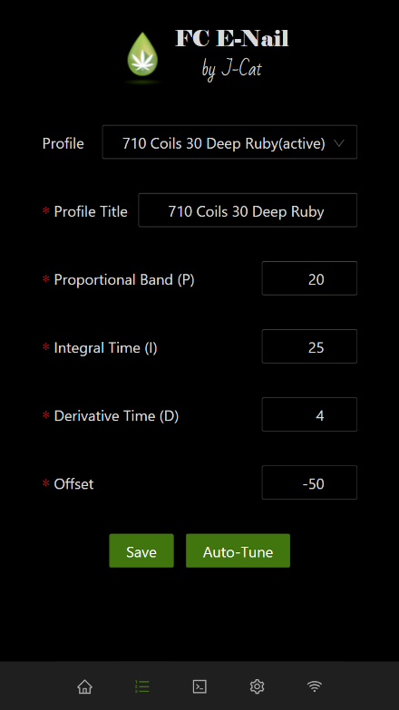

From the Profiles screen, you can:

* Create new profiles
* Edit existing profiles (the following is a very basic summary of what the values do, but is by no means accurate/exact):
  + Proportional Band (P) – controls how much power is injected into the coil to get to temperature; a higher value will mean more power and quicker temperature changes but can cause more overshoot
  + Integral Time (I) – affects how fast (the acceleration) of the temperature to the set temperature. Increases this will cause a quicker acceleration, and also can cause overshoot.
  + Derivative Time (D) – affects the deceleration of the temperature as it approaches the setpoint.
  + Offset – controls the offset of your coil from the actual temperature; for example, my 30mm coil reads @ about 50F to cool (floor temperature) when using my ruby insert, so I set the offset to -50 so that the temperature on the display reflects the floor temperature when using this coil/banger/insert combo.
* You can also run an auto-tune for each profile which automatically determines the P/I/D settings for your setup and saves them in the current profile. It is best to first let your setup reach temperature and stabilize for 5+ minutes before running an auto-tune procedure.

### Scripts

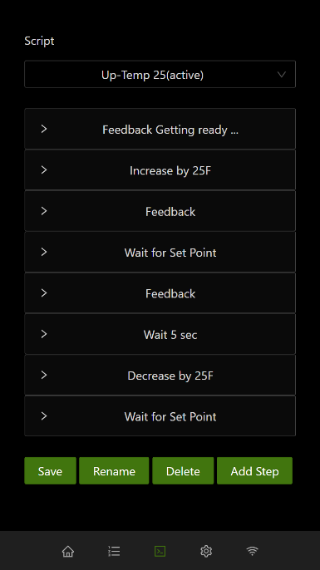 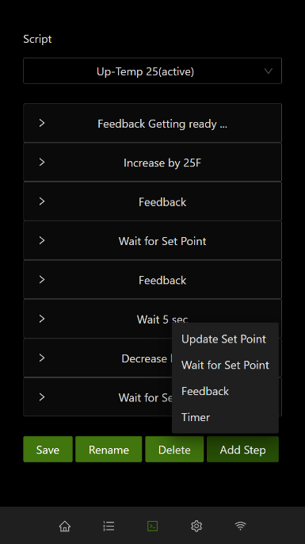 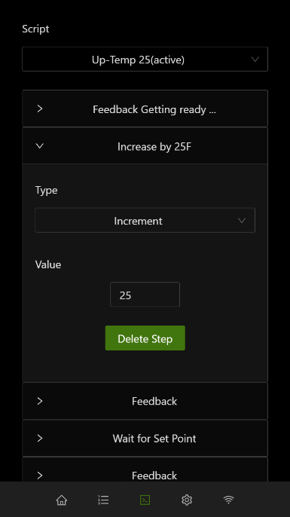 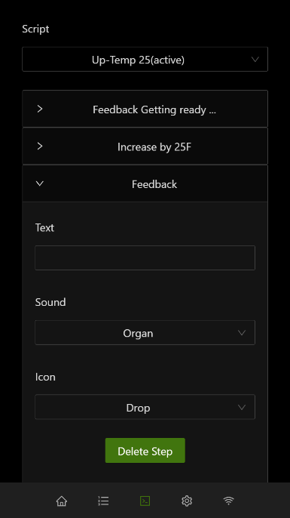 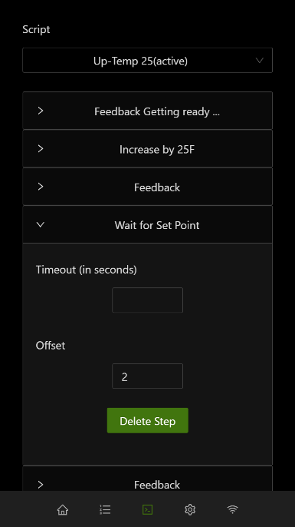 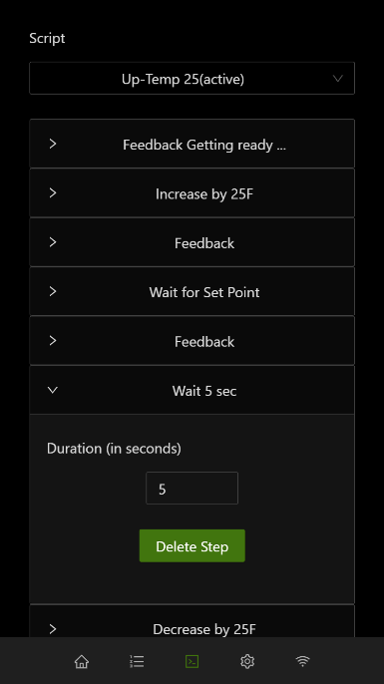

The Scripts screen allows one to create and edit custom scripts; scripts allow one to increase/decrease the temperature of your e-nail throughout a dab in a controlled and predictable fashion, with auditory and visual feedback.

The types of actions one can have in a script are:

* Update Set Point – adjusts the current temperature of the e-nail
* Wait for Set Point – waits until a temperature is reached (it is recommended to always use an offset of 2, or maybe 1 here, so that the action is triggered as the set point is approached.
* Feedback – displays visual feedback on the e-nail and the web app, as well as allows playing sounds
* Timer – waits a specified amount of time, in seconds, before continuing

### Settings

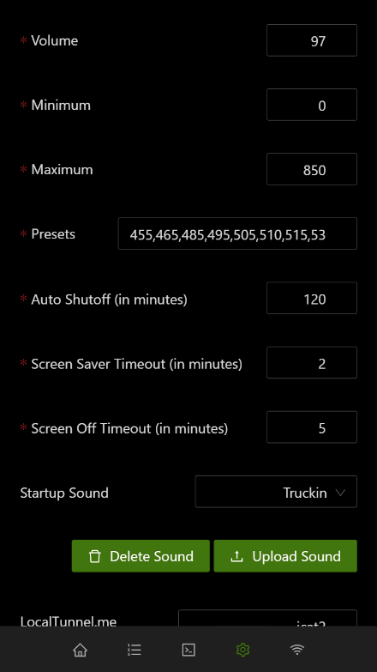 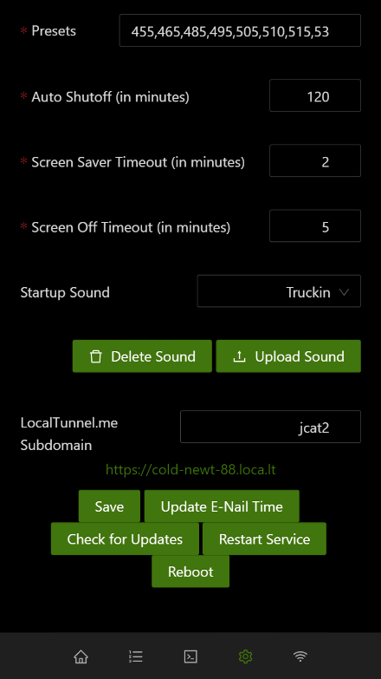

The Settings screen is used to adjust all the miscellaneous settings of the e-nail, as well as to initiate a few other actions such as restart/reboot, checking for updates, or updating the e-nail time from your connected device (phone, tablet, or PC/Mac).

The following are the settings available here:

* Volume
* Minimum/Maximum temperatures for the e-nail
* Preset temperatures (separated by commas)
* Auto Shutoff time in minutes
* Screen Saver Timeout in minutes
* Screen Off Timeout in minutes (only takes effect when the e-nail heater is off)
* Startup sound played when the device boots up
* LocalTunnel.me preferred subdomain name (setting this makes your e-nail available at https://<name>.loca.lt Your preferred subdomain may not always be available, especially if your e-nail failed to release it or there was a service outage, in which case the actual name it is running on will be displayed below it.

### Connect to WiFi

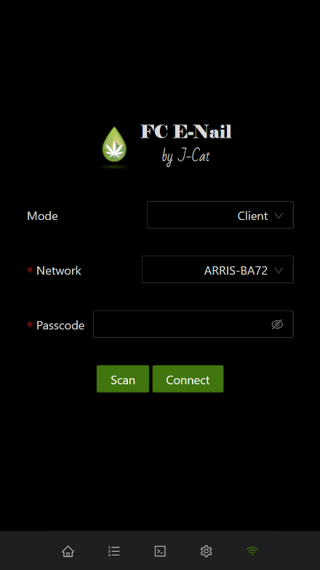

The Connect to WiFi screen is fairly self-explanatory. It allows you to scan for WiFi networks and then connect to them.

## Known Issues

The following are the current known issues with the device:

1. The LocalTunnel.me access is not always super stable, so it may lose it’s connection and reconnect with an unknown subdomain.